Part A

1.Chatgpt

2. Perplexity
Evaluation Criterion | Tool 1 | Tool 2
Name of AI tool | Leonardo AI | Recraft AI
Prompt followed correctly? | Yes | Yes
Human face appears realistic? | Yes | Yes
Skin texture appears natural? | Kinda | Yes
Eyes and hands are correct? | Yes | Yes
Airport environment is realistic? | Yes | Yes
Light comes from camera-left? | No | Yes
Uniform is professional? | Yes | Yes
Unwanted text or logos present? | No | No
Image looks AI-generated? Why? | No | No
Overall score out of 10 | 8 | 8.5

Answer each question in 2–3 sentences.
1. Which tool followed the prompt more accurately?
The Gemini image followed the prompt more accurately because it shows the airline executive standing at a check-in counter with a tablet and airport equipment. The ChatGPT image also follows the prompt, but it focuses more closely on the executive and provides less of the check-in environment.
2. Which image appeared more realistic?
Both images look realistic, with natural facial features, professional uniforms, and blurred airport backgrounds. The ChatGPT image has a polished corporate-photography appearance, while the Gemini image has a more cinematic and detailed airport setting.
3. What differences did you observe in lighting?
The Gemini image uses warm, soft natural lighting coming from the left, creating a welcoming and slightly golden atmosphere. The ChatGPT image uses brighter, cooler lighting with blue tones, giving it a clean and professional airport appearance.
4. Did either image contain distorted eyes, hands or facial features?
Neither image shows obvious distortion in the eyes or facial features. The Gemini image displays the executive's hands holding a tablet naturally, while the ChatGPT image has the hands mostly outside the frame, making them difficult to evaluate.
5. Which image would you use on an airline’s website?
I would use the ChatGPT image for an airline's website because its clean composition, professional portrait style, and blue uniform create a polished brand presentation. The Gemini image would also work well for promotional material highlighting airport customer service and the check-in experience.
6. What is the “visual accent” of each model?
The Gemini image has a warm, cinematic visual accent, with golden lighting, a detailed airport environment, and an emphasis on the employee's work setting. The ChatGPT image has a cool, professional corporate accent, using blue tones, bright lighting, and a closer portrait composition to communicate with a modern airline brand.

Part B

1.Leonardo AI

2.Canva Ai
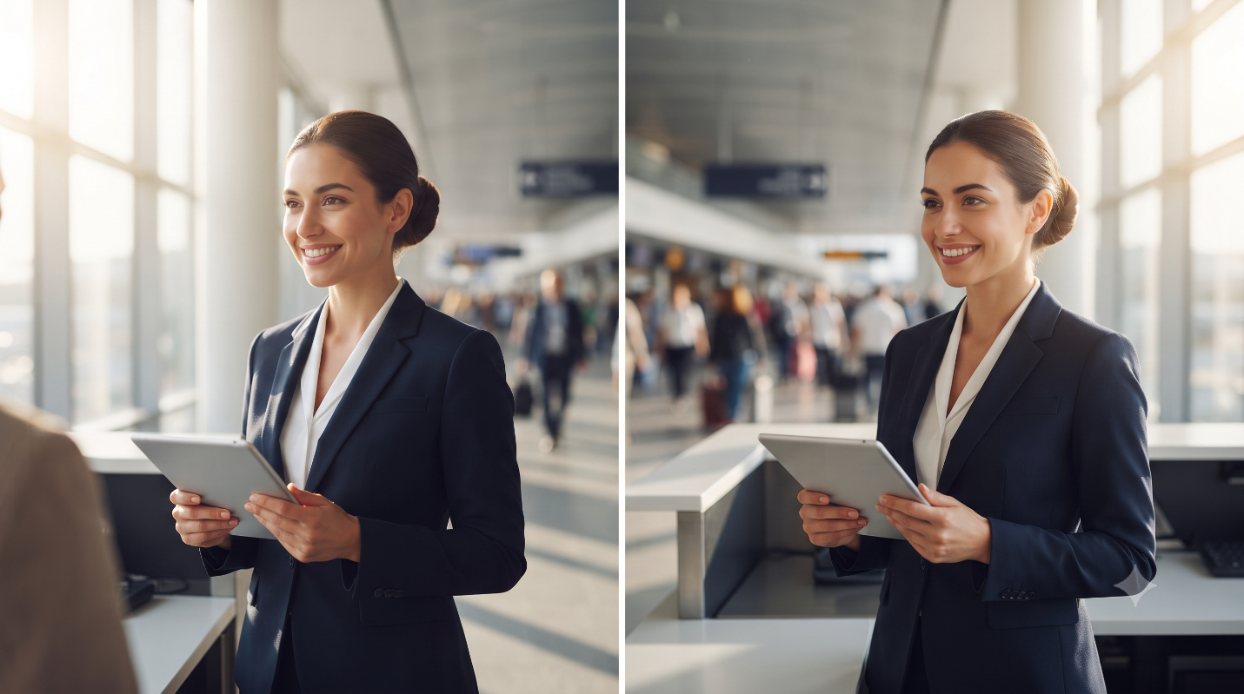
Question | Observation
Did the lighting direction change? | Yes
Was camera-left followed correctly? | Yes
Was camera-right followed correctly? | Yes
Did the background remain consistent? | Yes
Did the person’s appearance change? | Yes
Which instruction was ignored, if any? | No

